Advanced Comic Book Format
Creation How To
Licence
This work is licensed under the Creative Commons Attribution-ShareAlike 3.0 Unported License. To view a copy of this license, visit http://creativecommons.org/licenses/by-sa/3.0/ or send a letter to Creative Commons, 444 Castro Street, Suite 900, Mountain View, California, 94041, USA.

Document History
Version | Date | Author | Description
0.1 | 4.5.2012 | Róbert Pastierovič | Initial version
0.2 | 30.10.2012 | Róbert Pastierovič | Improved chapter about frames extraction from SVG file

Used Abbreviations
Abbreviation | Description
ACBF | Advanced Comic Book Format
CBR, CBZ | Comic Book Archive file format (last letter defines how it is compressed R = RAR, Z = Zip etc.)
XML | Extensible Markup Language

Contents
Introduction 4
Creation of simple CBZ file 4
Meta-data Section 5
Body Section 7
Title 8
Text layer and text area 8
Frames/panels definition 9
Frames and text areas creation using Inkscape 10
Data section 12

Introduction
This document explains how to easily create comic book in ACBF format for those who are interested in ACBF comic books creation.
Creation of comic book text layer requires usage of shell scripts (created for Linux), so I'm not sure if these can be run under Windows or Mac.

Creation of simple CBZ file
The easiest way to start creating ACBF is to create CBZ file first. CBZ file is a ZIP archive of images, each image representing one comic book page.
CBZ Viewers require that image file names are sorted in ascending order, so that the first comic book page comes out sorted first, second page second etc. This is done usually by naming images with numbers:
page01.jpg
page02.jpg
page03.jpg
...
Most Vievers (ACBF Viewer as well) support directories structure inside CBZ file:
Chapter01/
page01.jpg
page02.jpg
page03.jpg
...
Chapter02/
page01.jpg
page02.jpg
page03.jpg
...
...
Directories are sorted first, then image files inside each directory are sorted afterwards. So after you prepared all files, you may compress them using preferred ZIP archiver, then rename the resulting file from [comic book filename].zip to [comic book filename].cbz.
The reason why we created CBZ file first is that ACBF Viewer is capable of working with this file format and internally after unzipping the file contents it creates simple ACBF file containing basic page structure with references to individual files.
So after opening CBZ file in ACBF Viewer look inside ACBF temporary storage directory ~/.local/share (in Linux) or C:\Documents and Settings\[username]\acbfv (in Windows). There you should find uncompressed all comic book files as well as corresponding .acbf file. You can copy all these files to your working directory (note that when opening new file ACBF Viewer deletes all files/directories from inside here).
Contents of created ACBF file should look similar to this:
<ACBF xmlns="http://www.fictionbook-lib.org/xml/acbf/1.0">
<meta-data>
<book-info>
<coverpage>
<image href="page01.jpg"/>
</coverpage>
</book-info>
<publish-info/>
<document-info/>
</meta-data>
<body>
<page>
<image href="page02.jpg"/>
</page>
<page>
<image href="page03.jpg"/>
</page>
<page>
<image href="page04.jpg"/>
</page>
<page>
<image href="page05.jpg"/>
</page>
<page>
<image href="page06.jpg"/>
</page>
<page>
<image href="page07.jpg"/>
</page>
<page>
<image href="page08.jpg"/>
</page>
<page>
<image href="page09.jpg"/>
</page>
<page>
<image href="page10.jpg"/>
</page>
</body>
</ACBF>
First page is automatically considered as a coverpage.

Meta-data Section
Meta-data section of the ACBF document contains information describing the comic book itself (title, author, genre …), publishing information (publisher, year, license ...) and information about this particular document we are creating (creation date, author, document history, source …). Meta-data section is inside <meta-data> XML tag.
Our created simple ACBF file contains just the coverpage definition in the meta-data section. You may fill in more information like in the example below:

<ACBF xmlns="http://www.fictionbook-lib.org/xml/acbf/1.0">
<meta-data>
<book-info>
<author activity="Writer">
<first-name>Ryan</first-name>
<last-name>Estrada</last-name>
</author>
<author activity="Artist">
<first-name>Ryan</first-name>
<last-name>Estrada</last-name>
</author>
<book-title>The Kind You Don't Take Home to Mother</book-title>
<genre>romance</genre>
<characters>
<name>David Duncan</name>
<name>Julia</name>
<name>Mr. Herb Duncan</name>
<name>Mrs. Duncan</name>
</characters>
<annotation>
<p>David comes home to introduce his girlfriend to his parents. But she's not like a normal girl, she's special ... she's a werewolf.</p>
<p>Colorful short comic story by Ryan Estrada. Originally published online by DC Comics.</p>
</annotation>
<coverpage>
<image href="page01.jpg"/>
</coverpage>
<languages>
<text-layer lang="en" show="False"/>
<text-layer lang="en" show="True"/>
<text-layer lang="sk" show="True"/>
</languages>
</book-info>
<publish-info>
<publisher>Róbert Pastierovič</publisher>
<publish-date>2011</publish-date>
<city>Bratislava, Slovakia</city>
<isbn>N/A</isbn>
<license>Creative Commons Attribution-NonCommercial-ShareAlike 3.0 Unported</license>
</publish-info>
<document-info>
<author>
<nickname>jrw</nickname>
</author>
<creation-date value="2012-01-17">January 17th 2012</creation-date>
<source>
<p>The Kind You Don't Take Home to Mother</p>
<p>Ryan Estrada, 2009</p>
<p>http://ryanestrada.com/thekindyoudonttakehometomother/index.html</p>
</source>
<id>jrw-estrada-the-kind-0123456789</id>
<version>0.5</version>
<history>
<p>v 0.1 – Initial Conversion</p>
</history>
</document-info>
</meta-data>
...
For detailed information how to fill all possible tags in this section and what they mean refer to ACBF Specification document.
The only thing that requires further explanation at this point is the <languages> element. Here are defined document text layers. As you can see the first text layer is defined as English (lang=”en”) and it is defined as a background layer only (show=”False”), which means that the text layer is not drawn over the background image even if it is present inside the document. Background image possibly contains original lettering already and comic book can be read without drawing text layer over it. Second defined text layer is also English (lang=”en”) but this time the texts are drawn over the background image (show=”True”). Third text layer is Slovak (lang=”sk”) and is drawn over the background image as well.

Body Section
Body section contains the definition of individual comic book pages, text layers and frames/panels definition inside those pages. Our sample ACBF file already contains all comic book pages which are referencing image files corresponding to each comic book page.
...
<body>
<page>
<image href="page02.jpg"/>
</page>
<page>
<image href="page03.jpg"/>
</page>
<page>
<image href="page04.jpg"/>
</page>
<page>
<image href="page05.jpg"/>
</page>
<page>
<image href="page06.jpg"/>
</page>
<page>
<image href="page07.jpg"/>
</page>
<page>
<image href="page08.jpg"/>
</page>
<page>
<image href="page09.jpg"/>
</page>
<page>
<image href="page10.jpg"/>
</page>
</body>
...

Title
To any <page> element we can add <title>. This serves for the purpose of indexing individual comic book pages and automatic creation of Table of Contents by the Viewer application. All pages containing <title> will get into Table of Contents.
...
<body>
<page>
<title lang="en">Old Lady</title>
<title lang="sk">Stará pani</title>
<image href="page02.jpg"/>
</page>
...
</body>
...
If you have more text layers inside the document make sure to include language definition in <title> element. This has to match text layers definition (<language> element) from meta-data section as described earlier.

Text layer and text area
Text layer inside the <page> element defines a particular text layer (for example English or Slovak). Each text layer then contains definition of individual text areas (i.e. text bubbles) which contain texts and optionally text semantics.
In the example below you can see a page on which English and Slovak text layers are defined with one text area inside.
...
<body>
<page>
<title lang="en">Old Lady</title>
<title lang="sk">Stará pani</title>
<image href="page02.jpg"/>
<text-layer lang="en" bgcolor="#ddb12a">
<text-area points="63,61 68,57 374,57 379,62 379,93 374,97 67,97 63,93" bgcolor="#ffffff">
<p>CRAPHOUND HAD <emphasis>WICKED</emphasis> YARD-SALE KARMA FOR A ROTTEN, FILTHY ALIEN BASTARD.</p>
</text-area>
</text-layer>
<text-layer lang="sk" bgcolor="#ddb12a">
<text-area points="63,61 68,57 374,57 379,62 379,93 374,97 67,97 63,93" bgcolor="#ffffff">
<p>CRAPHOUND, MAL AKO ZHNILÝ, ŠPINAVÝ MIMOZEMSKÝ PARCHANT <emphasis>HRIEŠNU</emphasis> KARMU OBCHODNÍKA.</p>
</text-area>
</text-layer>
</page>
...
</body>
...
Inside the <text-layer> element you define language attribute and optionally also background color. This background color is used to draw background of text areas (bubbles) unless it is overridden in particular <text-area> element.
Inside the <text-area> element you define the polygon of particular bubble with its (optional) background color. If no background color is defined, background color from <text-layer> element is inherited. Text area polygon is defined by couples of x,y coordinates that define position on background image in pixels.
Text inside <text-area> element is automatically fit into this area by Viewer application using the best font height possible. Note that styles (fonts, font colors etc.) are not (yet) defined as part of ACBF specifications.
Text inside the <text-area> element can contain optional semantics markup like <emphasis> as shown in example.

Frames/panels definition
Individual comic book panels on particular comic book page are defined by <frame> elements as seen in example below.
...
<body>
<page>
<title lang="en">Old Lady</title>
<title lang="sk">Stará pani</title>
<image href="page02.jpg"/>
<text-layer lang="en" bgcolor="#ddb12a">
...
</text-layer>
<frame points="45,36 500,35 500,445 44,446"/>
<frame points="510,35 963,35 965,442 511,443"/>
<frame points="22,551 550,549 552,922 21,921"/>
<frame points="545,452 965,452 965,807 985,807 990,812 995,822 995,832 991,837 982,847 973,852 969,857 969,1017 550,1017"/>
<frame points="44,1028 551,1030 553,1492 44,1491"/>
<frame points="565,1027 965,1027 965,1427 980,1507 971,1517 907,1508 898,1533 744,1514 749,1495 565,1495"/>
</page>
...
</body>
...
Point attribute contains couples of x,y coordinates that define particular panel/frame polygon defined over the background image. Coordinates are in pixels. If panels/frames are defined viewer application can then zoom in to particular frame and view the whole comic book page frame by frame.

Frames and text areas creation using Inkscape
As there is no editor for ACBF files creation it is not easy to define frames and text areas over the background image. Inkscape which is a open source editor for vector images can be used. File format used by Inkscape is SVG which is XML based format and therefore after drawing polygons over the background image we can take out the x,y polygon coordinates out of the resulting SVG file and put it inside ACBF file.
First open the background image in Inscape editor:

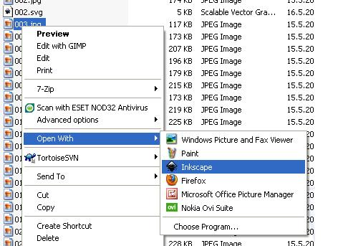

When asked to link or embed image, select link.

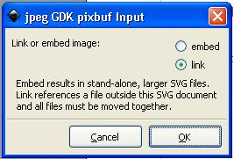
After image is loaded, select View->Grid to display grid which will help you in drawing polygons around the comic book panels.
Also select File->Inkscape Preferences, then from the menu on the left side select SVG output and make sure that “Allow relative coordinates” item under “Path Data” is unchecked.
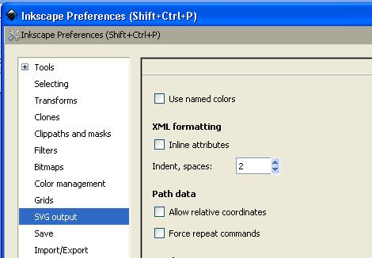
From toolbar on the left side choose “Draw Brezier curves and straight lines” tool.

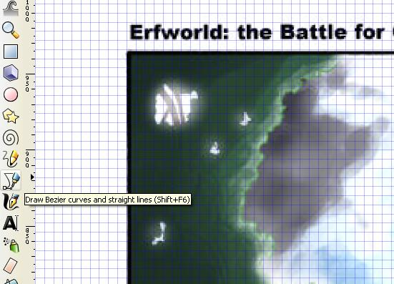

In the upper left corner select “Create a sequence of straight line segments” as drawing mode.

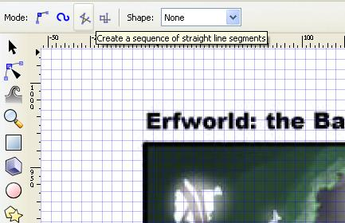
Now you're ready to draw polygons. Draw polygon around the desired area by clicking on underlying grid intersections. After you click on the starting point polygon will enclose.

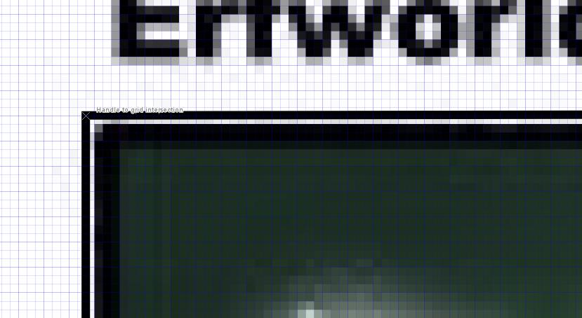
Continue until all comic book panels/frames are drawn on particular comic page. You may draw different kinds of shapes not just rectangles. Now save the file in SVG format. When you view the resulting SVG file in a text editor you will see your polygons defined inside the <path> XML tag:
<path
style="fill:none;stroke:#000000;stroke-width:1px;stroke-linecap:butt;stroke-linejoin:miter;stroke-opacity:1"
d="m 5,23 692,-1 1,233 -693,0 z"
id="path2989"
inkscape:connector-curvature="0" />
“d” attribute contains polygon coordinates. These coordinates may be written down in different ways, e.g. absolute values (capital M at the beginning), relative values (m), curves (c) … for more information see SVG file format specifications.
For an easy converting of these coordinates into XML tags used in ACBF format I created two simple shell scripts: extract_frames.sh (for extracting comic book panels coordinates) and extract_texts.sh (for extracting text-area coordinates). Both shell scripts can be found in \trunk\Sample Comic Book\Source location inside ACBF repository (direct internet link is http://bazaar.launchpad.net/~just-me/acbf/trunk/files/head:/Sample%20Comic%20Book/Source/). To extract polygon information from SVG file you need to run this scripts under linux/unix shell.
./extract_frames.sh page01.svg
Both scripts take one input parameter which is the name of SVG file. ACBF XML tags with coordinates will be written to standard output from which you can copy it to your .acbf file.
whale@Dag:~/Work/ACBF/trunk/Sample Comic Book/Source$ ./extract_frames.sh page1.svg
<frame points="45,36 500,33 500,443 43,444"/>
<frame points="510,35 962,34 965,441 510,442"/>
<frame points="22,551 550,548 552,921 20,919"/>
<frame points="44,1028 551,1030 553,1491 42,1490"/>
<frame points="565,1027 965,1027 965,1427 980,1507 970,1517 905,1507 895,1532 740,1512 745,1492 560,1492"/>
<frame points="545,452 965,452 965,807 985,807 990,812 995,822 995,832 980,847 970,852 965,857 965,1022 540,1022 545,662 530,662 520,657 505,652 500,642 500,632 510,622 520,617 540,612 540,587 525,582 525,572 530,567 540,567 545,562 545,452"/>
Total frames: 6

Data section
Data section is an optional section at the end of the acbf file which contains binary data. In the meantime (ACBF version 1.0) you can store here comic book images. All images has to be converted to BASE-64 and properly defined with a unique id.
<data>
<binary id="cover.jpg" content-type="image/jpg">/9j/4AAQSkZJRgAB
...
AqVKlQAqVKlQAqVKlQB//9k=</binary>
</data>
This way the whole comic book can be put into one single file and no CBZ container is needed.

